**Exp-10 Intermediate Code Generation (ICG)**

**Quadruples, Triples, Indirect triples**

**Name: -** Sai Mohit Ambekar

**Reg No: -** RA1911031010137

**Class: -** CSE-IT (L2 Section)

**Aim:**

To implement Intermediate code generation – Quadruples, Triples, Indirect triples.

**Algorithm:**

The algorithm takes a sequence of three-address statements as input. For each three address statements of the form a:= b op c perform the various actions. These are as follows: -

1. Invoke a function getreg to find out the location L where the result of computation b op c should be stored.

2. Consult the address description for y to determine y'. If the value of y currently in memory and register both then prefer the register y' . If the value of y is not already in L then generate the instruction MOV y' , L to place a copy of y in L.

3. Generate the instruction OP z' , L where z' is used to show the current location of z. if z is in both then prefer a register to a memory location. Update the address descriptor of x to indicate that x is in location L. If x is in L then update its descriptor and remove x from all other descriptors.

4. If the current value of y or z have no next uses or not live on exit from the block or in register then alter the register descriptor to indicate that after execution of x : = y op z those register will no longer contain y or z.

**Program:**

#include <stdio.h>

#include <ctype.h>

#include <stdlib.h>

#include <string.h>

void small();

void dove(int i);

int p[5] = {0, 1, 2, 3, 4}, c = 1, i, k, l, m, pi;

char sw[5] = {'=', '-', '+', '/', '*'}, j[20], a[5], b[5], ch[2];

int main()

{

printf("Enter the expression: ");

scanf("%s", j);

printf("The Intermediate code is:\n");

small();

}

void dove(int i)

{

a[0] = b[0] = '\0';

if (!isdigit(j[i + 2]) && !isdigit(j[i - 2]))

{

a[0] = j[i - 1];

b[0] = j[i + 1];

}

if (isdigit(j[i + 2]))

{

a[0] = j[i - 1];

b[0] = 't';

b[1] = j[i + 2];

}

if (isdigit(j[i - 2]))

{

b[0] = j[i + 1];

a[0] = 't';

a[1] = j[i - 2];

b[1] = '\0';

}

if (isdigit(j[i + 2]) && isdigit(j[i - 2]))

{

a[0] = 't';

b[0] = 't';

a[1] = j[i - 2];

b[1] = j[i + 2];

sprintf(ch, "%d", c);

j[i + 2] = j[i - 2] = ch[0];

}

if (j[i] == '*')

printf("t%d=%s*%s\n", c, a, b);

if (j[i] == '/')

printf("t%d=%s/%s\n", c, a, b);

if (j[i] == '+')

printf("t%d=%s+%s\n", c, a, b);

if (j[i] == '-')

printf("t%d=%s-%s\n", c, a, b);

if (j[i] == '=')

printf("%c=t%d\n", j[i - 1], --c);

sprintf(ch, "%d", c);

j[i] = ch[0];

c++;

small();

}

void small()

{

pi = 0;

l = 0;

for (i = 0; i < strlen(j); i++)

{

for (m = 0; m < 5; m++)

if (j[i] == sw[m])

if (pi <= p[m])

{

pi = p[m];

l = 1;

k = i;

}

}

if (l == 1)

dove(k);

else

exit(0);

}

**Output:**

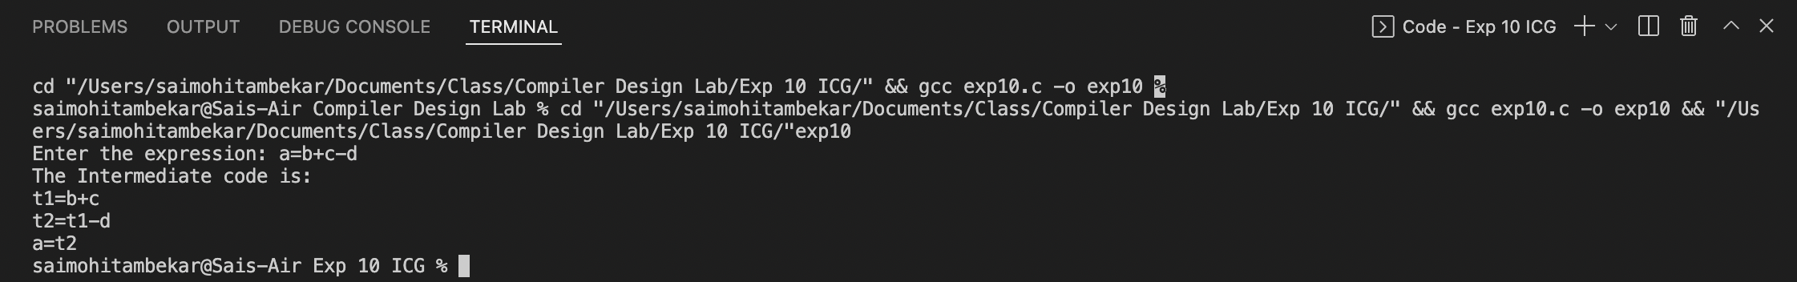

**Result:**

The program was successfully compiled and run.